Implementation

主要让他看看这个格式对不对，如果不对的话应该怎么描述prototype。

Prototype

This software is designed as a learning tool instead of a game according to requirements we gathered.

To clarify, the grey blocks are expected to be images or animations.

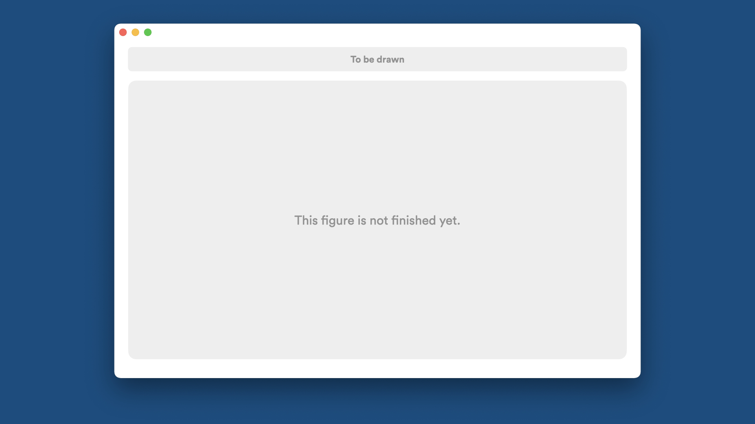

Figure 1. Ask master level

In this page, the software asks user’s master level of sorting algorithms. User may choose their level. The less the user knows about sorting algorithms, the more basic things the software will show. After user clicked one button, go to Figure 2.



Figure 2. User guide

In this page, the software will briefly introduce which symbols are of what use. User will gain basic understanding of how to use the software. Then go to Figure 3.

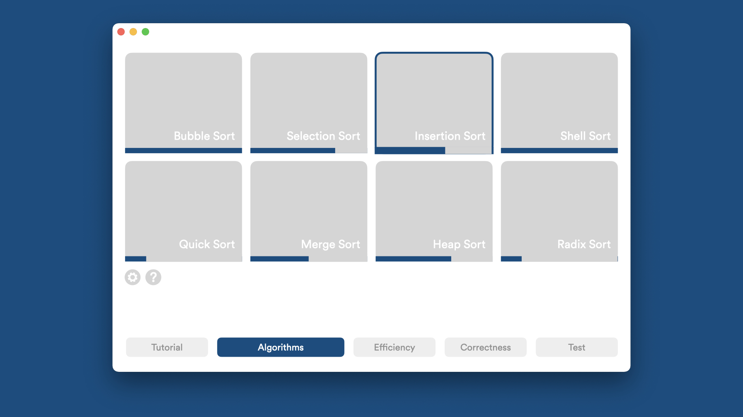

Figure 3. Algorithms.

This is the Algorithm part, and the representative colour of it is blue, which will be discussed later. In this page, the software shows all sorting algorithms supported to be learnt and user’s progress.

Each Algorithm block is a button to be clicked. The blue bar at the bottom of the block, is a progress bar, to show the user’s learning progress percentage in this algorithm. If the block is stroke, like the Insertion Sort block in this figure, it means this algorithm is recently accessed by the user.

At the bottom of the window shows our designed learning modules. Click one of them, the user will jump into another module with a different representative colour, like the Correctness part will be red.

The Setting button will lead user to the Setting window, and the Question button will get into user guide again, in case the user doesn’t remember what does our design mean.